Nic Falcione

CPSC 498

2/18/2020

Weekly Update #2

1. What progress have you made since the last meeting, including specific items that were completed, and the time spent on each item?

I have created an RDS instance on Amazon Web Services that will store the course information for my website. I spent 1.5 hours on this. I created my EC2 instance on AWS using the micro option and spent 1 hour on this. I encountered a bug where I did not ensure the instances were on the same Virtual Private Cloud and it took me 1.5 hours to fix this. I created an interactive Kanban board on “Kanbanflow.com” which took about 20 minutes. I also created subsequent security groups, subnet groups, and other configurations to my instances and this took about 1 hour.

1. What progress you expect to make in the upcoming week, including specific items, and time estimates on how much time you will spend on them?

I plan to develop my database schema for the computer science courses at CNU and add the other PCSE majors if time permits. I will expect this to take 2-3 hours. I plan on populating the database with these courses and I expect this to take about 2 hours.

1. Any changes you have identified that will result in your final project being different than your project proposal. This information must be recorded in 3 ways.

I do not have any changes planned for my final project that differ from my project proposal.

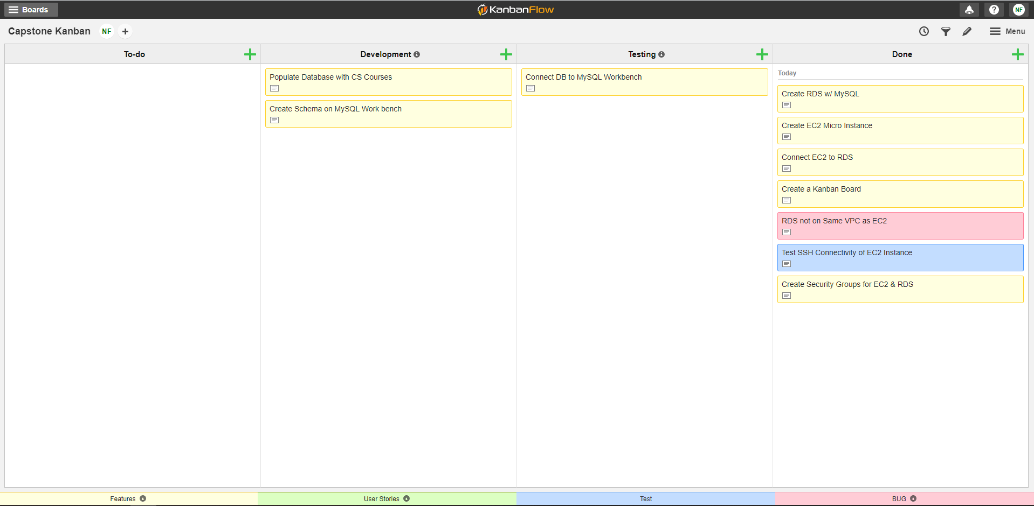

Figure 1: My Kanban Board